July
2020  The Ministry to Generation Z course begins on Tuesday, July 7, 2020. Each three-week section begins on a Tuesday and ends on the third Monday. | 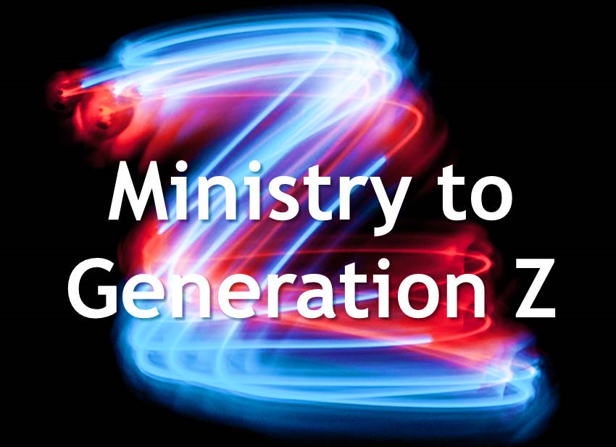
Sunday | Monday | Tuesday | Wednesday | Thursday | Friday | Saturday
 |  |  | 1 | 2 | 3 | 4
 |  |  | Complete Pre-Course Activities
5 | 6 | 7 | 8 | 9 | 10 | 11
 |  | Zoom Chat |  |  | Section 1-A Forum Post
12 | 13  Section 1-A Forum  Responses | 14 | 15 | 16 | 17 | 18
19 | 20 | 21 | 22 | 23 | 24 | 25
 | Section 1-B Forum  Responses & Prayer Journal | Section 1-B Forum Post
26 | 27 | 28 | 29 | 30 | 31
 |  | Zoom Chat

August
2020
The Ministry to Generation Z course begins on Tuesday, July 7, 2020. Each three-week section begins on a Tuesday and ends on the third Monday. The course ends on September 28, 2020.
Sunday | Monday | Tuesday | Wednesday | Thursday | Friday | Saturday
 |  |  |  |  |  | 1
2 | 3 | 4 | 5 | 6 | 7 | 8
 |  | Gen Z Interviews and Section 2-B Forum Post  Section 2-A Forum Post |  |  | Section 2-A Forum  Responses
9 | 10 | 11 | 12 | 13 | 14 | 15
Section 2-B Forum
Responses & Prayer Journal
16 | 17 | 18 | 19 | 20 | 21 | 22
 |  | Zoom Chat
23 | 24 | 25 | 26 | 27 | 28 | 29
 |  | Section 3-A Forum Post |  |  | Section 3-A Forum  Responses
30 | 31

September
2020
The Ministry to Generation Z course begins on Tuesday, July 7, 2020. Each three-week section begins on a Tuesday and ends on the third Monday. The course ends on September 28, 2020.
Sunday | Monday | Tuesday | Wednesday | Thursday | Friday | Saturday
 |  | 1 | 2 | 3 | 4 | 5
 | Section 3-B Forum  Responses& Prayer Journal | Gospel Presentation Project Due |  |  | Section 3-B Forum Post
6 | 7 | 8 | 9 | 10 | 11 | 12
 |  | Zoom Chat
13 | 14 | 15 | 16 | 17 | 18 | 19
 |  | Section 4-A Forum Post |  |  | Section 4-A Forum  Responses
20 | 21 | 22 | 23 | 24 | 25 | 26
 | Section 4-B Forum  Responses& Prayer Journal | Discipleship Project Due |  |  | Section 4-B Forum Post
27 | 28 | 29 | 30

